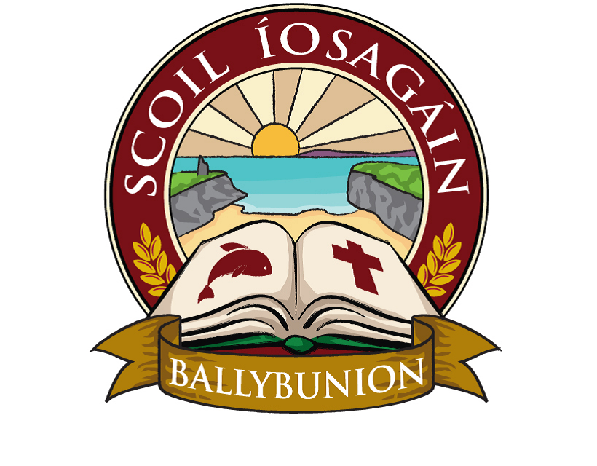
Scoil Íosagáin Ballybunion
Health and Safety Statement

In accordance with the Safety, Health and Welfare at Work Act 2005, it is the policy of the Board of Management of Scoil Íosagáin Ballybunion to ensure, in so far as is reasonably practicable, the safety, health and welfare at work of all staff and to protect pupils, visitors, contractors and other persons at the school from injury and/or ill health arising from any work activity. The successful implementation of this policy requires the full support and active co-operation of all staff, contractors and pupils of the school.
It is recognised that hazard identification, risk assessment and control measures are legislative requirements which must be carried out by the employer to ensure the safety, health and welfare of all staff.
The Board of Management undertakes, in so far as is reasonably practicable to:
- Promote standards of safety, health and welfare that comply with the provisions and requirements of the Safety, Health and Welfare at Work Act 2005 and other relevant legislation, standards and codes of practice
- Provide information, training, instruction and supervision where necessary, to enable staff to perform their work safely and effectively
- Maintain a constant and continuing interest in safety and health matters pertinent to the activities of the school
- Continually improve the systems in place for the management of occupational safety and health and review it periodically to ensure it remains relevant, appropriate and effective
- Consult with staff on matters related to safety, health and welfare at work
- Provide the necessary resources to ensure the safety, health and welfare of all those to whom it owes a duty of care, including staff, pupils, contractors and visitors.
The Board of Management is committed to playing an active role in the implementation of this occupational safety and health policy and undertakes to review and revise it in light of changes in legislation, experience and other relevant developments.
Signed:
___________________________________
Joan Murphy, Chairperson, Board of Management
Date: 01/12/2021

